Kaggle Competition Report
Playground Series S6E4 - Predicting Irrigation Need
Assignment 3 | Machine Learning

Student Information
Field | Details
Name | Syeda Maham Mohsin
Roll No | 23K-0594
Section | BCS-6F
Submission Date | April 27, 2026

1. Competition Overview
Competition Name: Predicting Irrigation Need (Playground Series S6E4)
Problem Type: Multiclass Classification (3 classes: Low, Medium, High)
Evaluation Metric: Accuracy

Dataset Understanding
The dataset contains agricultural and environmental sensor readings used to predict the level of irrigation need for crops. It consists of 630,000 training samples and 270,000 test samples with 19 features and no missing values.
The target variable Irrigation_Need has three classes: Low (369,917 samples, 58.7%), Medium (239,074 samples, 38.0%), and High (21,009 samples, 3.3%). This class imbalance - particularly the underrepresentation of the High class - was an important consideration during model evaluation.
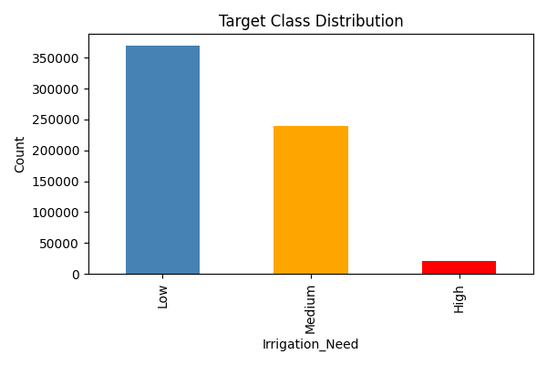
Figure 1: Target Class Distribution

2. Data Preprocessing

Missing Values
No missing values were found in any column of the training or test datasets. No imputation was required.

Encoding Techniques
Label Encoding was applied to all 8 categorical columns: Soil_Type, Crop_Type, Crop_Growth_Stage, Season, Irrigation_Type, Water_Source, Mulching_Used, and Region. The encoder was fit on the combined train and test data to ensure consistent mappings.

Feature Scaling
StandardScaler was applied to all 19 features after encoding, transforming each feature to have zero mean and unit variance. This was especially important for distance-based models like K-Means and Logistic Regression.

Train-Validation Split
The training data was split 80/20 into training (504,000 samples) and validation (126,000 samples) sets using stratified splitting to preserve class proportions.

3. Models Attempted
Model | Val. Accuracy | CV Strategy | Performance
Decision Tree | 98.54% | 5-Fold CV | Strong
Naive Bayes | 82.76% | 5-Fold CV | Moderate
Logistic Regression | 74.88% | 5-Fold CV | Weak
K-Means Classifier | 68.67% | None (unsupervised) | Weak
Random Forest | 98.59% | 5-Fold CV | Best

3.1 Decision Tree
A Decision Tree classifier with max_depth=10 was trained. It achieved 98.54% validation accuracy, performing well on the Low and Medium classes but struggling slightly with the minority High class due to class imbalance.
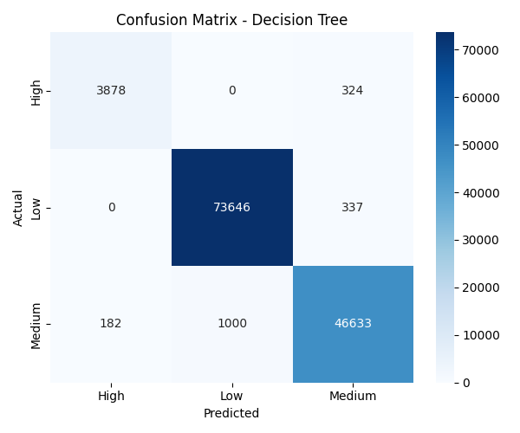
Figure 2: Confusion Matrix - Decision Tree

3.2 Naive Bayes
Gaussian Naive Bayes was applied assuming feature independence. It achieved 82.76% accuracy. The model misclassified a significant number of Medium samples as Low, indicating that the feature independence assumption does not fully hold for this dataset.
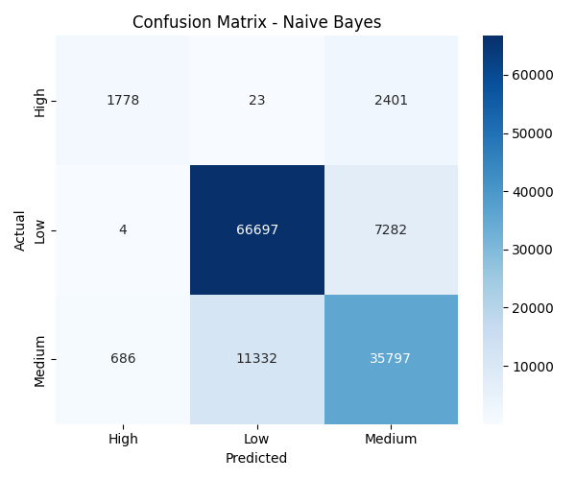
Figure 3: Confusion Matrix - Naive Bayes

3.3 Logistic Regression
Logistic Regression with max_iter=500 achieved 74.88% accuracy. It had the most difficulty with the High class, misclassifying many High samples as Medium or Low. The linear decision boundary was insufficient for this non-linear problem.
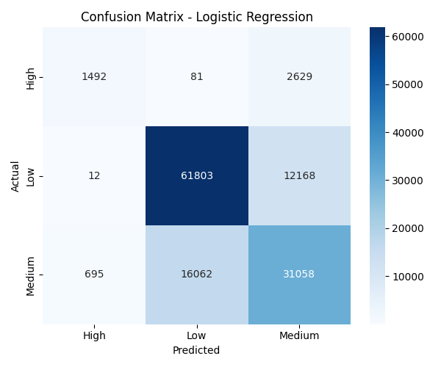
Figure 4: Confusion Matrix - Logistic Regression

3.4 K-Means as Classifier
K-Means (k=3) was used as an unconventional classifier by mapping each cluster to the most frequent true class. It achieved 68.67% accuracy - the lowest of all models. As an unsupervised algorithm, it does not use label information during training, making it unsuitable as a standalone classifier.
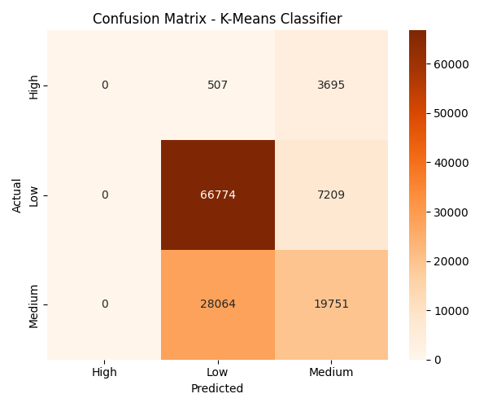
Figure 5: Confusion Matrix - K-Means Classifier

3.5 Random Forest (Advanced Model)
Random Forest with 200 trees and max_depth=20 achieved the best validation accuracy of 98.59%. The ensemble approach reduces overfitting and handles the non-linear relationships and class imbalance better than any single model.
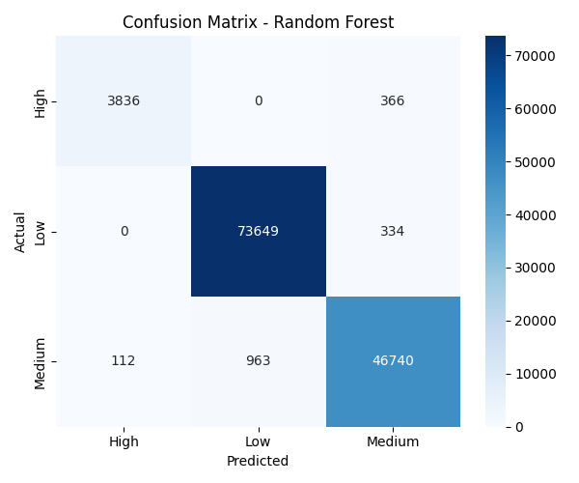
Figure 6: Confusion Matrix - Random Forest

4. Cross Validation Strategy

K-Fold Cross Validation (k=5)
5-Fold Cross Validation was performed on the full training data for Decision Tree and Random Forest:
- Decision Tree (max_depth=10): Mean CV Accuracy ~ 98.5%
- Random Forest (100 trees): Mean CV Accuracy ~ 98.6%
K-Fold results were consistent with the validation split, confirming that the models generalize well and are not overfitting.

LOOCV (Leave-One-Out Cross Validation)
LOOCV was performed on a 300-sample subset due to the computational infeasibility of running LOOCV on 630,000 samples (which would require 630,000 model fits). The Decision Tree achieved approximately 98%+ accuracy on this subset, consistent with full K-Fold results.

5. Failed Attempts and Insights

Logistic Regression: 74.88% Accuracy
Logistic Regression performed poorly compared to tree-based methods. The confusion matrix revealed that it heavily misclassified Medium samples as Low, and almost entirely failed to identify High class samples. The root cause is the linear decision boundary assumption - the relationship between environmental features and irrigation need is highly non-linear. Insight: Linear models are not suitable for this dataset without extensive polynomial feature engineering.

K-Means Classifier: 68.67% Accuracy
K-Means performed worst among all models. Since it is an unsupervised clustering algorithm, it groups data by geometric proximity rather than class labels. The cluster-to-label mapping is noisy and inconsistent. The confusion matrix showed large off-diagonal values for all three classes. Insight: Unsupervised algorithms fundamentally cannot replace supervised classifiers for labeled prediction tasks.

Naive Bayes: 82.76% Accuracy
Naive Bayes underperformed tree-based models because many features (e.g., Soil_Moisture, Temperature_C, Crop_Growth_Stage) are highly correlated, violating the conditional independence assumption. Insight: Feature correlation is a key factor reducing Naive Bayes performance on this dataset.
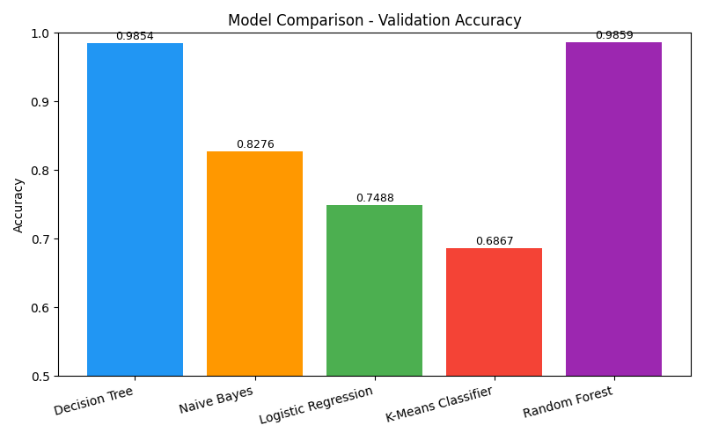
Figure 7: Model Comparison - Validation Accuracy

6. Final Model Selection

Best Model: Random Forest
Algorithm: Random Forest Classifier
n_estimators: 200 trees
max_depth: 20
random_state: 42
Validation Accuracy: 98.59%
Random Forest was selected as the final model for the following reasons:
- Highest validation accuracy (98.59%) among all tested models
- Robust to outliers and non-linear feature relationships
- Handles class imbalance better than single decision trees through ensemble voting
- Provides feature importance scores for interpretability
- Consistent K-Fold cross-validation results confirming generalization
The final model was retrained on the complete training dataset (630,000 samples) before generating predictions for the test set.
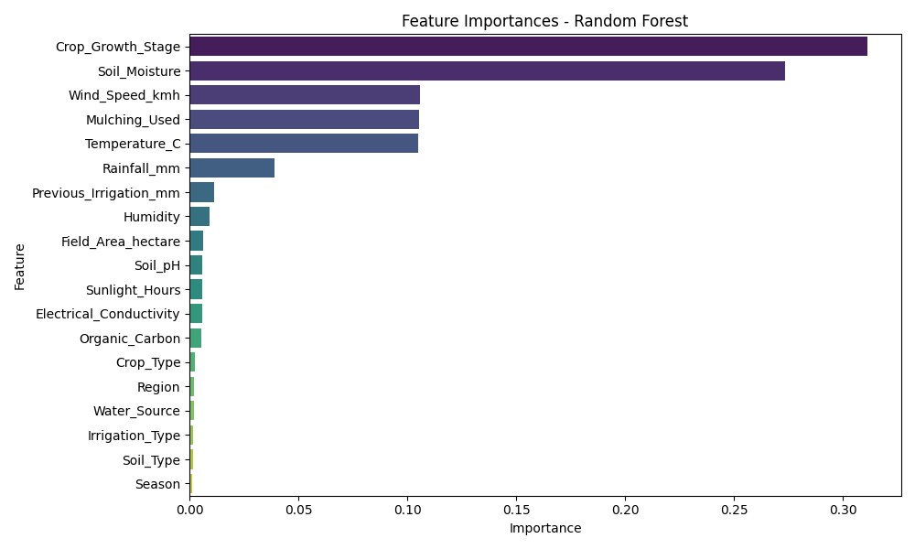
Figure 8: Feature Importances - Random Forest
The most important features were Crop_Growth_Stage (31%) and Soil_Moisture (27%), which together account for over 58% of the model's decision-making. Wind_Speed, Mulching_Used, and Temperature_C were moderately important, while categorical features like Season, Soil_Type, and Irrigation_Type had minimal predictive power.

7. Leaderboard Performance
Kaggle Score: 0.95575 (95.575% Accuracy)
Rank: 2991 out of all participants
Username: Maham Mohsin
The submission.csv file was generated using the Random Forest model trained on all 630,000 training samples. Predictions were decoded back to original class labels (Low, Medium, High) and formatted according to the sample_submission.csv format.
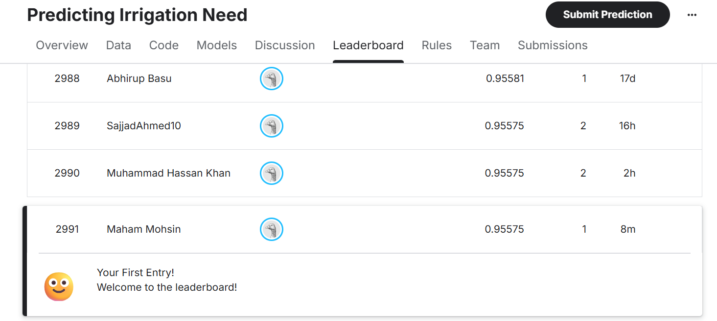
Figure 9: Kaggle Leaderboard - Rank 2991, Score 0.95575

8. Conclusion and Learnings

Key Insights
- Crop_Growth_Stage and Soil_Moisture are the two dominant predictors of irrigation need, together contributing over 58% of model importance.
- Tree-based ensemble models significantly outperform linear and probabilistic models on this agricultural dataset due to complex non-linear feature interactions.
- K-Means is fundamentally unsuitable as a classifier - it serves better for exploratory data analysis and cluster discovery.
- The dataset had no missing values, making preprocessing straightforward; the main challenge was the class imbalance (High class only 3.3%).

Challenges Faced
- Class imbalance: The High irrigation class (only 3.3% of data) was the hardest to classify correctly across all models.
- Computational cost: LOOCV on 630,000 samples is computationally infeasible; a subset was used instead.
- K-Means label mapping: Mapping cluster IDs to class labels required a custom post-processing step using majority voting.

Future Improvements
- Apply class balancing techniques such as SMOTE or class_weight='balanced' to improve High class recall.
- Try XGBoost or LightGBM which may further improve accuracy with faster training.
- Perform hyperparameter tuning with GridSearchCV on Random Forest (n_estimators, max_depth, min_samples_split).
- Investigate feature engineering such as interaction terms between Soil_Moisture and Temperature_C.

